**PRANAVA HOSPITAL**

**INTRODUCTION**

Pranava Hospital is a comprehensive healthcare institution focused on delivering quality medical services. This document provides an ER Diagram and the structure of tables used in the hospital's database, including Patient Insurance, Employee, Patient Appointment, Patient Lab Report, Patient Disease, and Patient. It also covers the contents of each table and explores various Joins, Views, Stored Procedures, and Subqueries used to manage and retrieve data effectively within the hospital's database system.

**ER DIAGRAM**

**STRUCTURE OF TABLES**

**1.PATIENT INSURANCE**

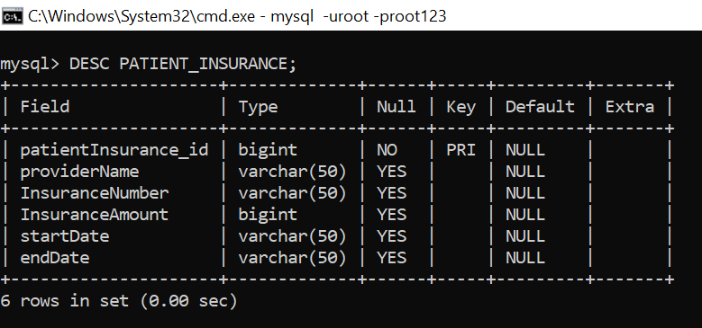

**2.EMPLOYEE**

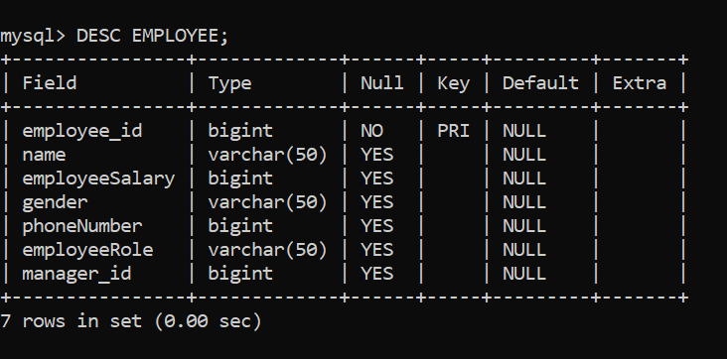

**3.PATIENT APPOINTMENT**

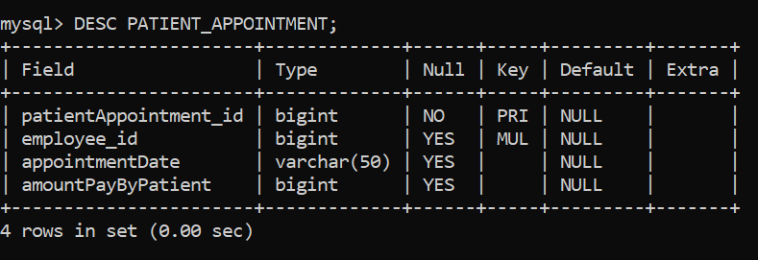

**4.PATIENT LAB REPORT**

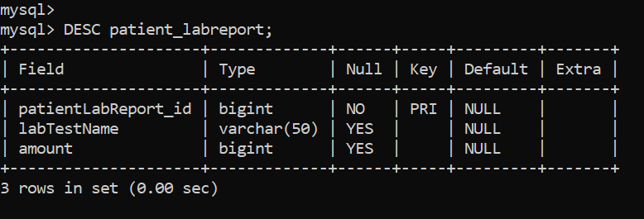

**5.PATIENT DISEASE**

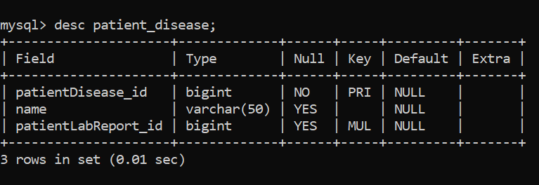

**6.PATIENT**

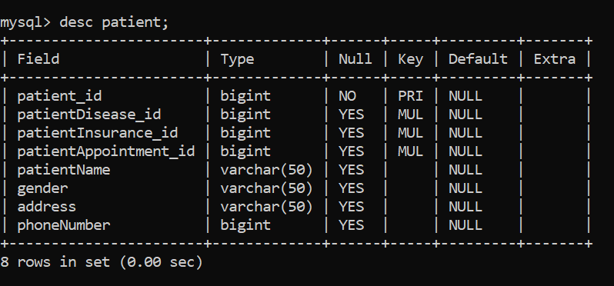

**CONTENTS OF TABLES**

**1.Patient Insurance**

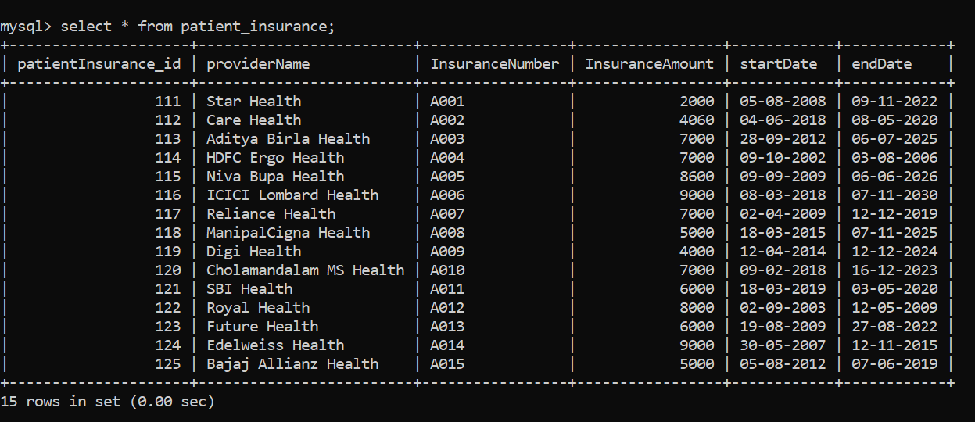

**2.Employee**

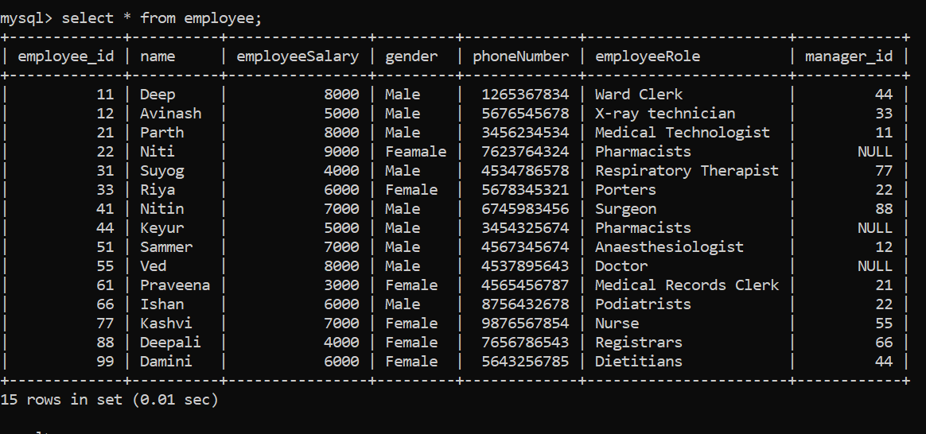

**3.Patient Appointment**

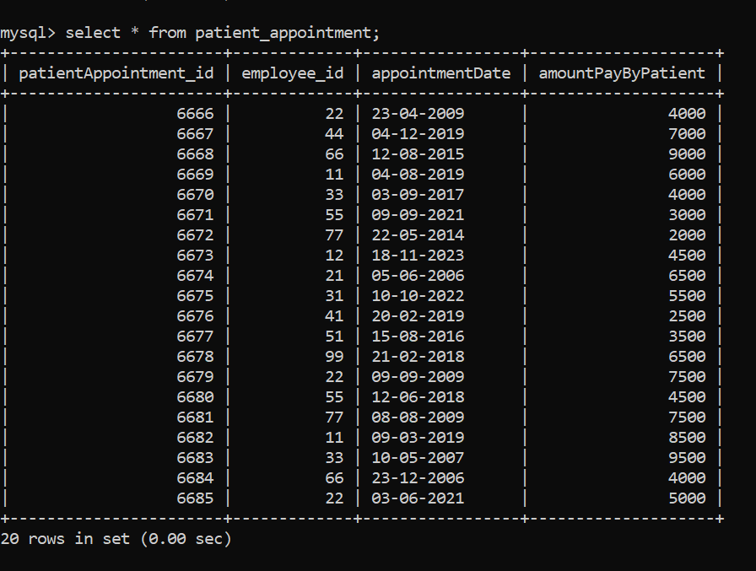

**4.Patient Lab Report**

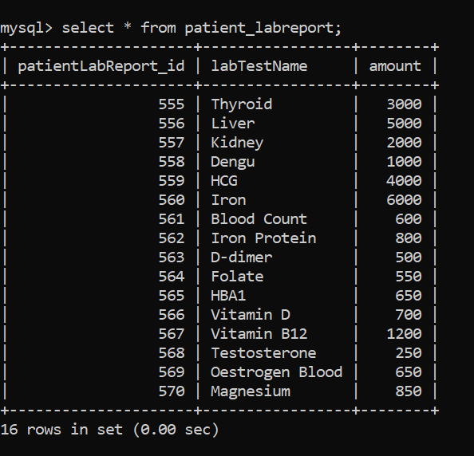

**5.Patient Disease**

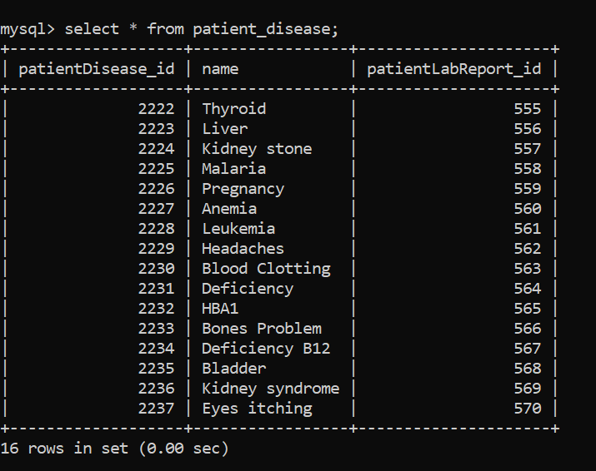

**6.Patient**

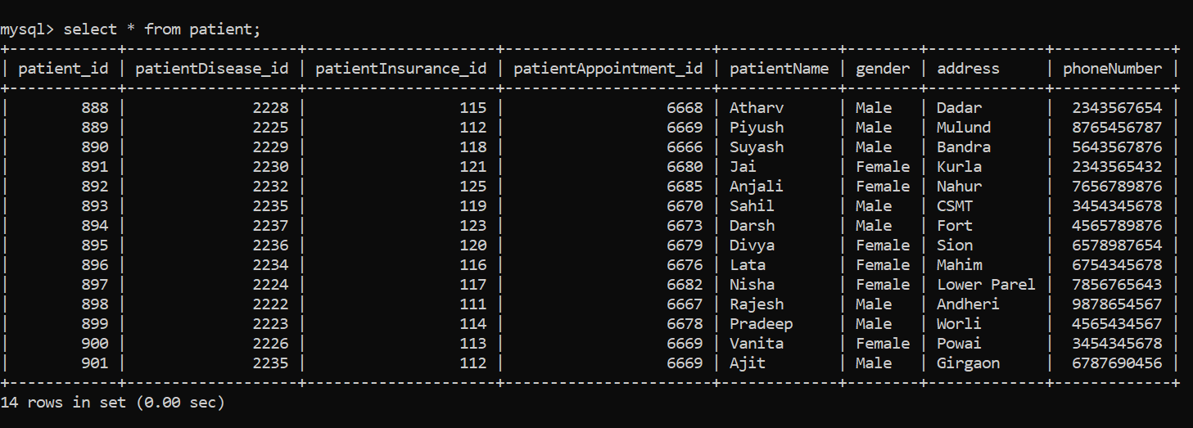

**JOINS**

**1.Display name of employees along with manager name.**

SELECT e1.name AS employee_name, e1.employeeRole AS employee_role,

e2.name AS manager_name, e2.employeeRole AS manager_role

FROM employee e1 JOIN employee e2 ON e1.manager_id = e2.employee_id;

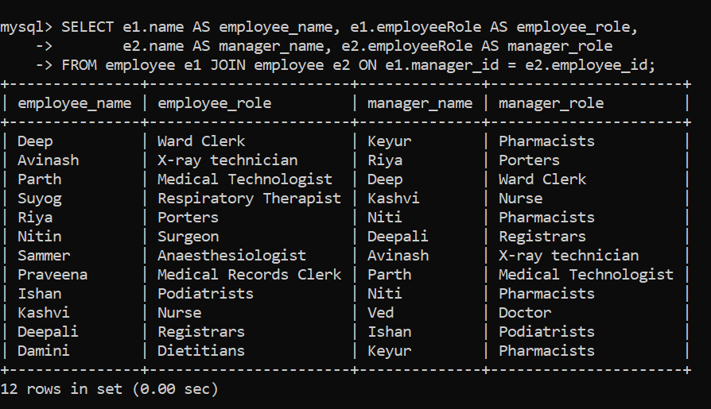

**2.Display name of disease along with lab test name.**

SELECT pd.patientDisease_id, pd.name AS disease_name, pl.patientLabReport_id, pl.labTestName, pl.amount FROM patient_disease pd LEFT JOIN patient_labreport pl ON pd.patientLabReport_id = pl.patientLabReport_id;

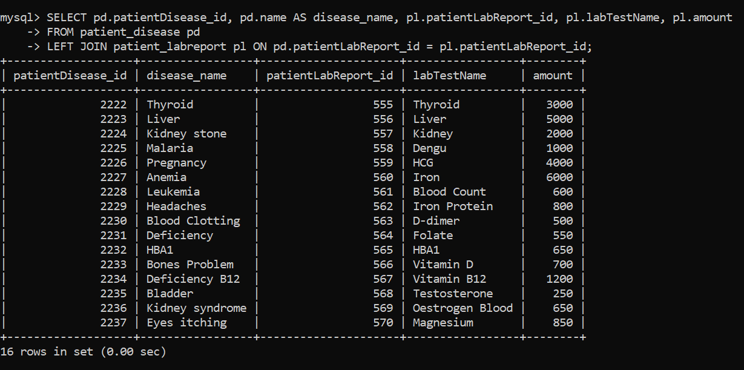

**3.Display name of employees along with appointment details using right join.**

SELECT e.employee_id, e.name AS employee_name, e.employeeSalary, e.gender, e.phoneNumber, e.employeeRole, pa.patientAppointment_id, pa.appointmentDate, pa.amountPayByPatient FROM employee e RIGHT JOIN patient_appointment pa ON e.employee_id = pa.employee_id;

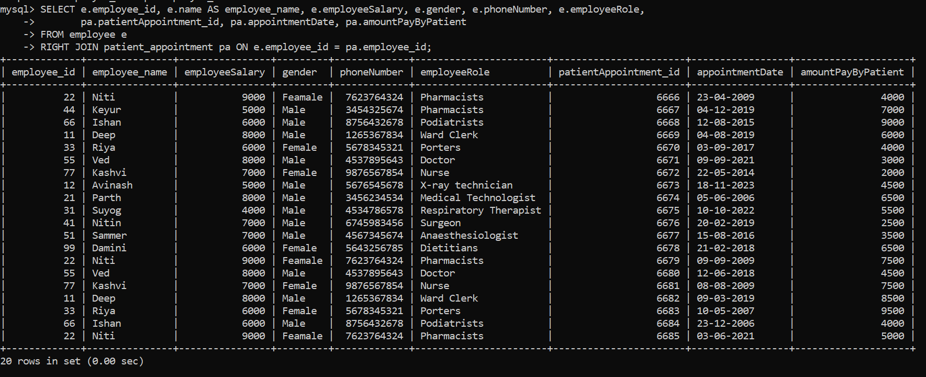

**VIEWS**

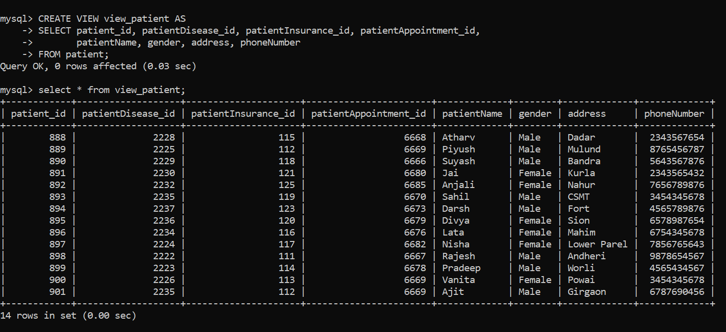

**STORED PROCEDURE**

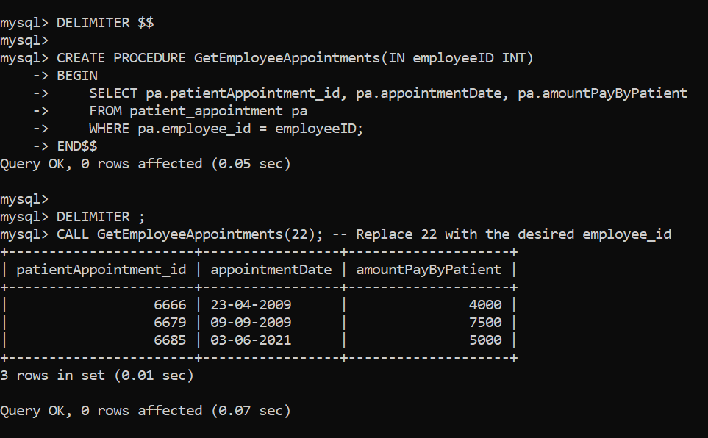

**SUBQUERY**

